Building Materials And The Climate: Constructing A New Future – Social Media Toolkit

Hashtags: #BuildingTheTransition #ClimateAction

Accounts to tag:
Twitter | Linkedin
@unep | UN Environment Programme
@Join_GlobalABC | Yale CEA
@yale | Global Alliance for Buildings and Construction (GlobalABC)

Link to Report: https://bit.ly/3EEdlHS

Social Media Messages
SM cards | Twitter | Linkedin
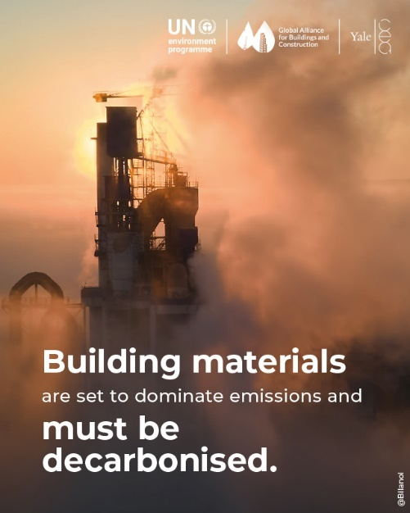 | ♻️ To achieve net-zero emissions in construction, we need materials from renewable/reusable sources.  Learn more in the new @UNEP, @Join_GlobalABC, @Yale Buildings Report👉 https://bit.ly/3EEdlHS  #BuildingTheTransition #ClimateAction | ♻️ To achieve net-zero emissions in construction, we must prioritize materials sourced from renewable and reusable origins.  Most climate action so far was dedicated to reducing “operational carbon” emissions of buildings (e.g., heating, cooling, lighting), but we also must address "embodied carbon" emissions stemming from building materials (e.g., cement, steel, aluminum). 🏗  Learn more in the new UN Environment Programme, Global Alliance for Buildings and Construction (GlobalABC) and Yale CEA, "Building Materials And The Climate: Constructing A New Future" Report.  Read here 👉 https://bit.ly/3EEdlHS  #BuildingTheTransition #ClimateAction
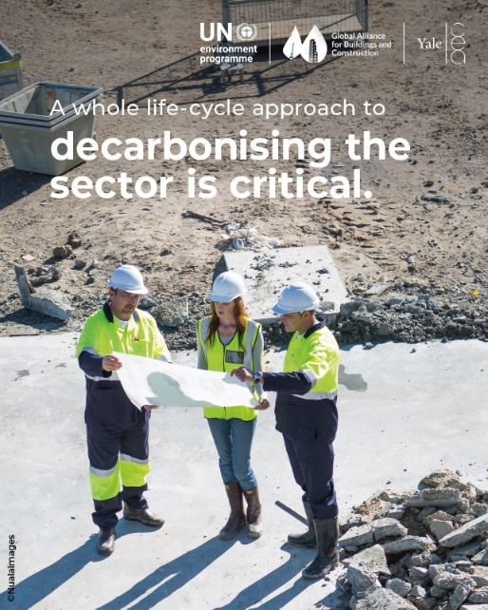 | Choosing the right materials is essential for our health, the climate, and ecosystems. 🏗️  Learn more in the new @UNEP, @Join_GlobalABC, @Yale Buildings Report👉 https://bit.ly/3EEdlHS  #BuildingTheTransition #ClimateAction | Choosing the right materials is essential for our health, the climate, and ecosystems. 🏗️  We must consider impacts at every step: extraction, processing, installation, use, and demolition and coordination between all buildings stakeholders is crucial 🤝  Learn more in the new UN Environment Programme, Global Alliance for Buildings and Construction (GlobalABC) and Yale CEA, "Building Materials And The Climate: Constructing A New Future" Report.  Read here 👉 https://bit.ly/3EEdlHS  #BuildingTheTransition #ClimateAction
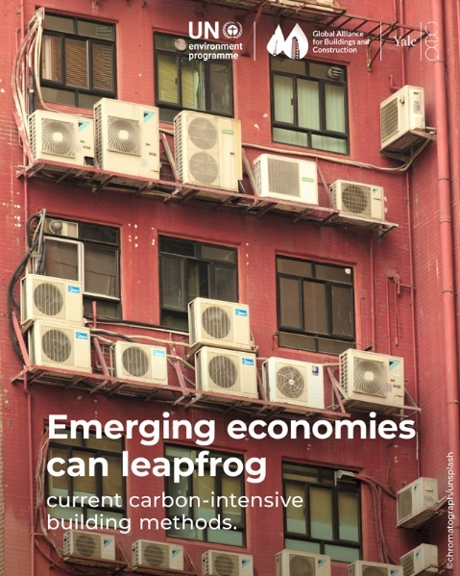 | 🚀 Emerging economies have the opportunity to embrace low-carbon building methods.  💪 Developed economies can channel resources into revitalizing aging structures.  Learn more in the new @UNEP, @Join_GlobalABC, @Yale Buildings Report👉 https://bit.ly/3EEdlHS  #BuildingTheTransition | 🚀 Emerging economies have the opportunity to embrace low-carbon building methods, bypassing carbon-intensive practices.  💪 Developed economies can channel resources into revitalizing aging structures.  Learn more in the new UN Environment Programme, Global Alliance for Buildings and Construction (GlobalABC) and Yale CEA, "Building Materials And The Climate: Constructing A New Future" Report.  Read here 👉 https://bit.ly/3EEdlHS  #BuildingTheTransition #ClimateAction
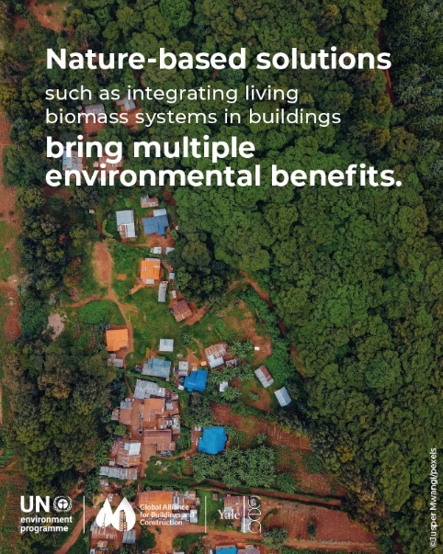 | 🌱 Mandating vegetated surfaces can naturally cool buildings, cut energy use, and combat flooding while nurturing urban biodiversity.  Learn more in the new @UNEP, @Join_GlobalABC, @Yale Buildings Report👉 https://bit.ly/3EEdlHS  #BuildingTheTransition #ClimateAction | 🌱 Mandating vegetated surfaces can naturally cool buildings, cut energy use, and combat flooding while nurturing urban biodiversity.  🌆 Cities worldwide are recognizing the power of vegetated surfaces (green roofs, façades, indoor walls), which can save up to 60% in energy compared to concrete walls!  Learn more in the new UN Environment Programme, Global Alliance for Buildings and Construction (GlobalABC) and Yale CEA, "Building Materials And The Climate: Constructing A New Future" Report.  Read here 👉 https://bit.ly/3EEdlHS  #BuildingTheTransition #ClimateAction
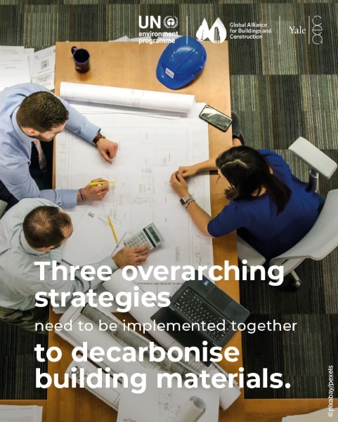 | To decarbonize buildings, we need a three-pronged approach:  1️⃣ Avoid unnecessary extraction & production.  2️⃣ Shift towards regenerative materials.  3️⃣ Improve decarbonization of conventional materials.  Read the new @UNEP, @Join_GlobalABC, @Yale Buildings Report👉 https://bit.ly/3EEdlHS | To tackle the carbon footprint of building materials, we need a three-pronged approach:  1️⃣ Avoid unnecessary extraction & production.  2️⃣ Shift towards regenerative materials.  3️⃣ Improve decarbonization of conventional materials.  Learn more in the new UN Environment Programme, Global Alliance for Buildings and Construction (GlobalABC) and Yale CEA, "Building Materials And The Climate: Constructing A New Future" Report.  Read here 👉 https://bit.ly/3EEdlHS  #BuildingTheTransition #ClimateAction
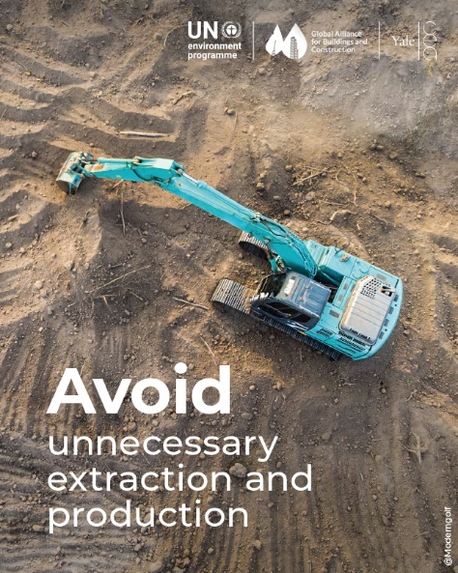 | Let's build a sustainable future by AVOIDING excessive raw material extraction & production! 🌍  Read the new @UNEP, @Join_GlobalABC, @Yale Buildings Report👉 https://bit.ly/3EEdlHS  #BuildingTheTransition #ClimateAction | Let's build a sustainable future by AVOIDING excessive raw material extraction and production! 🌍  🏢 Rethink building design, from planning to implementation, for minimal environmental impact.  Learn more in the new UN Environment Programme, Global Alliance for Buildings and Construction (GlobalABC) and Yale CEA, "Building Materials And The Climate: Constructing A New Future" Report.  Read here 👉 https://bit.ly/3EEdlHS  #BuildingTheTransition #ClimateAction
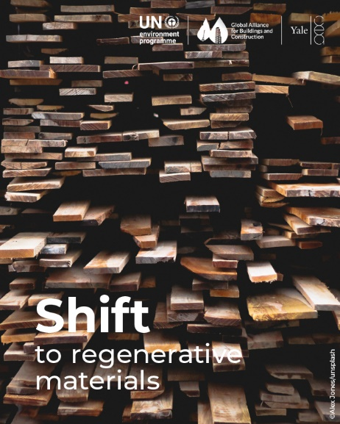 | Let's SHIFT towards regenerative materials in construction! 🌏  🏡 Choose ethically produced, low-carbon bio-based materials.  Read the new @UNEP, @Join_GlobalABC, @Yale Buildings Report👉 https://bit.ly/3EEdlHS  #BuildingTheTransition #ClimateAction | Let's SHIFT towards regenerative materials in construction! 🌏  🏡 Choose ethically produced, low-carbon bio-based materials like sustainable bricks, timber, bamboo, and agricultural/forest biomass to promote biodiversity.  📈 This shift could lead to massive emissions savings, up to 40% in the sector by 2050 in many regions!  Learn more in the new UN Environment Programme, Global Alliance for Buildings and Construction (GlobalABC) and Yale CEA, "Building Materials And The Climate: Constructing A New Future" Report.  Read here 👉 https://bit.ly/3EEdlHS  #BuildingTheTransition #ClimateAction
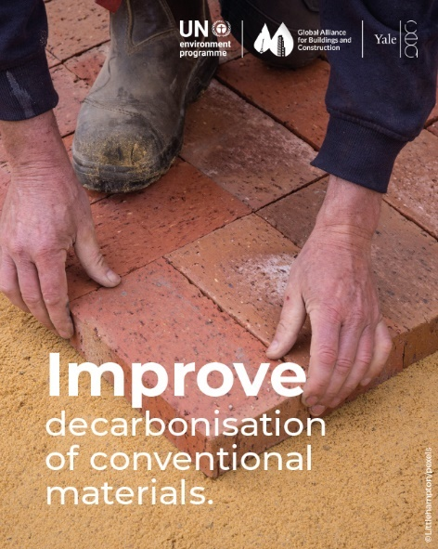 | Let's IMPROVE conventional building materials and processes, like concrete, cement, steel, iron, and aluminum, by decarbonizing! 🌍  Read the new @UNEP, @Join_GlobalABC, @Yale Buildings Report👉 https://bit.ly/3EEdlHS  #BuildingTheTransition #ClimateAction | Conventional Buildings materials, like concrete, cement, steel, iron, and aluminum, account for 23% of global greenhouse gas emissions!  Let's IMPROVE conventional building materials and processes through focused decarbonization! 🌍  Learn more in the new UN Environment Programme, Global Alliance for Buildings and Construction (GlobalABC) and Yale CEA, "Building Materials And The Climate: Constructing A New Future" Report.  Read here 👉 https://bit.ly/3EEdlHS  #BuildingTheTransition #ClimateAction

